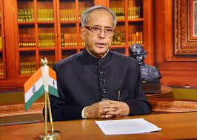  Shri Pranab Mukherjee  13th President of the Republic of India (2012-17)  Bharat Ratna (2019)  Padma Vibhushan (2008) | 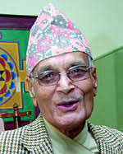  Shri Tulsi Giri  Former Prime Minister of Nepal
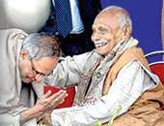  Prof. Debranjan Mukhopadhyay | 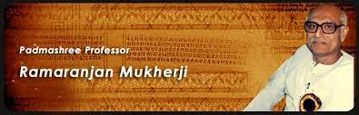  Prof. Ramaranjan Mukhopadhyay  Former Chancellor, Tirupati Rastriya Sanskrit Vidyapith (Deemed University) & Vice-Chancellor, BU & RBU
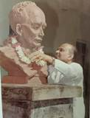  Prof. K. N. Chatterjee  V.C., N.B.U. |  | 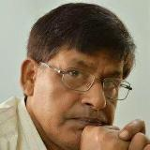  Prof. L. N. Mandal  Former Principal, SVC & Ex-V.C. Seacom Skill University
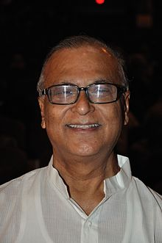  Shri Pradip Bhattacharyya  Member of Parliament , Rajyasabha | 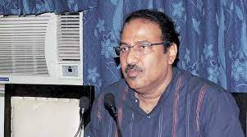  Shri Swapan Kanti Ghosh  Industrialist &Ex-MLA

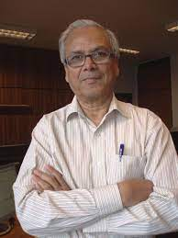  Prof. Amitava Ghosh  Ex-Director, IIT KGP  Senior Scientist IIEST, Shibpur | 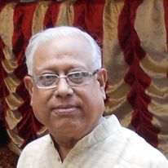  Prof. Amal Kr. Mukhopadhyay  Former Principal , Presidency College (University) | 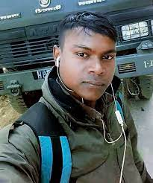  Rajesh Orang  Former NCC Cadet & Solder  Martyr in china-Ladakh Clash
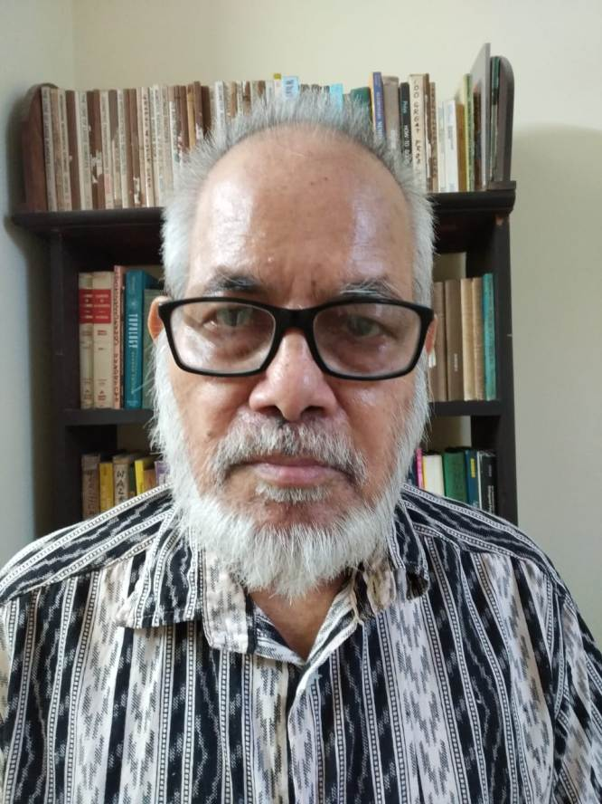  Prof. Khitish Chandra Chattopadhyay  Department of Mathematics  The University of Burdwan | 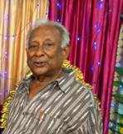  Prof. Krishna Kinkar Mandal  Department of Mathematics  The University of Burdwan | 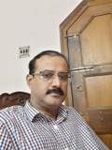  Prof. Amar Kumar Banerjee  Department of Mathematics  The University of Burdwan

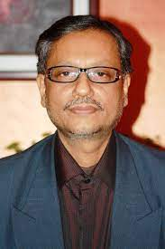  Goutam Chandra, Ph.D., D.Sc.  (Siksha Ratna-2017)  Professor, Department of Zoology  The University of Burdwan | 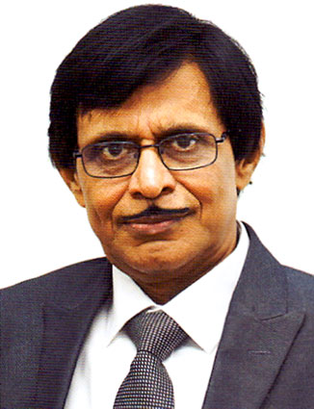  Puspitaranjan Bhattacharya, Ph.D  (Siksha Ratna-2015)  Principal, Heritage College  Ex-Principal, Suri Vidyasagar College & Vijoygarh Jyotish Roy College | 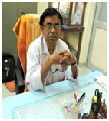  Subrata Mondal, Ph.D.  Professor, Department of Botany  Visva Bharati

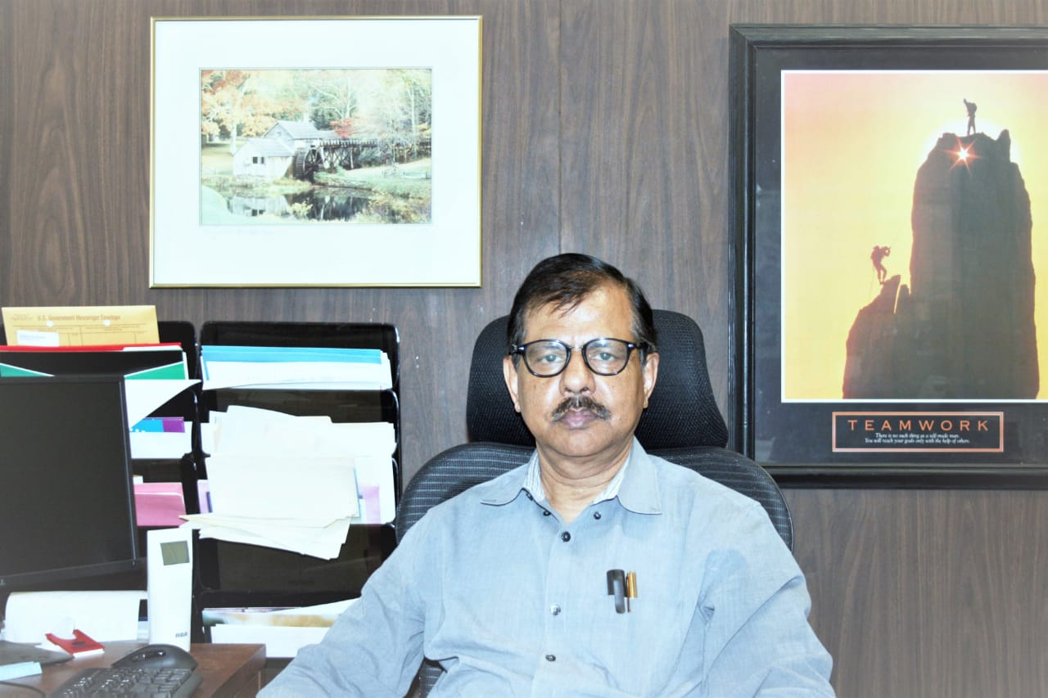  Sushanta K. Banerjee, Ph.D.  Professor, Department of Pathology & Laboratory Medicine  University of Kansas Medical Center, Kansas City, Kansas  Research Director, Cancer Research Unit, VAMC | 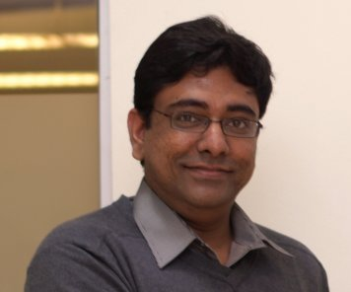  Sangram Bagh, Ph.D., F.R.S.  Biophysics & Structural Genomics Division  SINP,Kolkata

Prominent Alumni of Suri Vidyasagar College
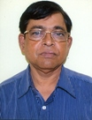  Prof. Debprasad Chattopadhyay, Ph.D.  Director, ICMR-NITM  Karnataka | 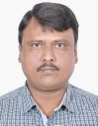  Prof. Arijit Ghosal, Ph.D.  Department of Mathematics  B.U. |  | 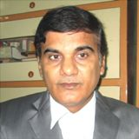  Susanata Kumar Bardhan, Ph.D.  Associate Prof. of English,  Suri Vidyasagar College
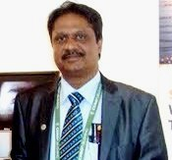  Prof. Amal Kr. Mondal, Ph.D.  Department of Botany &Forestry, V.U. |  | 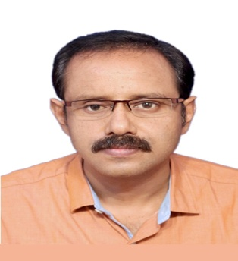  Hirok Chaudhuri, Ph.D.  Associate Prof., NIT, Durgapur |  | 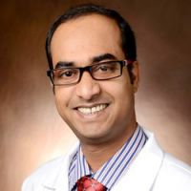Nandan Kr Mondal, Ph.D.  Baylor College of Medicine  Houston, TX US
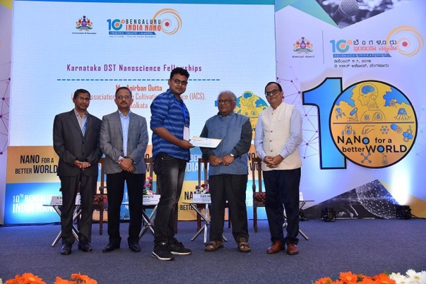  Anirban Dutta, Ph.D.  (Receiving DST Nano Science Award)  SRO,IOCL,R&D |  | 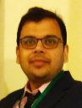  Prof. Debajyoti Ghoshal, Ph.D.  Inorganic Chemistry Section, JU, Kolkata. |  | 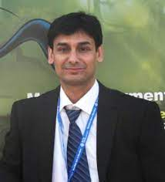  Prof. Subhas Banerjee, Ph.D.  Dept. of Chemistry  Guru Ghasidas Univ.  Bilaspur, Chhattishgarh.
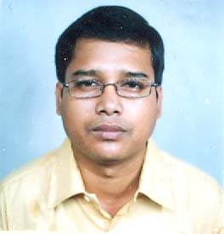  Maidul Hossain, Ph.D.  Department of Chemistry & Chemical Technology  Assistant Prof., V.U |  | Tanmay Chatterjee, Ph.D.  Assistant Prof.,BITS Pilani, Hyderabad |  | Md. Maidul Islam, Ph.D.  Dept. of Chemistry & Medicinal Chemistry  Aliah University, Kolkata
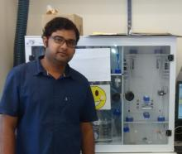  Priyadip Das, Ph.D.  Department of Chemistry  SRM Institute of Science & Technology |  | 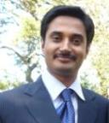  Surojit Pande, Ph.D.  Department of Chemistry  BITS, Pilani, Rajasthan |  | 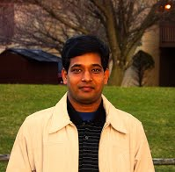  Sukhendu Mandal, Ph.D.  Department of Microbiology  Calcutta University
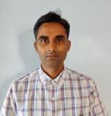  Debabrata Saha  Assistant Prof. of Chemistry  Suri Vidyasagar College |  | 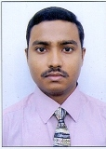  Aritra Chakrabarti, WBICS  Assistant Director of Information, Information & Cultural Affairs Deptt., GoWB. |  | 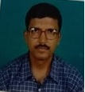  Subrata Sinha, Ph.D.  Associate prof. of chemistry  Mahadevananda Mahavidyalaya
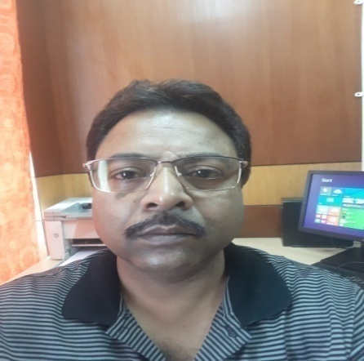  Sandip K. Dutta, WBCS (E)  Additional Director (Census)  MSME Directorate  &  Joint Secretary to GoWB |  | 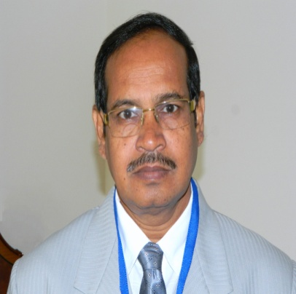  Nikhil Kumar Sinha, Ph.D.  (Botany, 1981)  Head Master, Rampurhat High School  “National Teacher” Award-2015 |  | 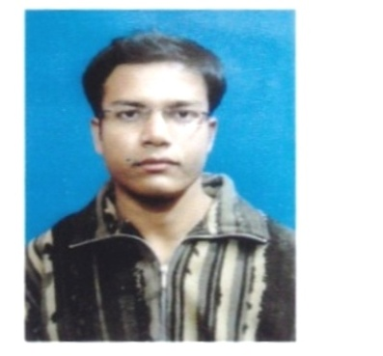  Surajit Das, Assistant Prof.  Department of Philosophy  Mathabhanga College  Coochbehar

